# Install Instructions for PLDBBatchProcess

Note: Batch Server running this process will require:

* ArcGIS 10.2.1
* ArcFM 10.2.1 a
* SQL Server Native Client 2012
* SQL Server Management Studio version 17.7

## Step 1. Run the setup msi

- right click on the msi

- PGE Install Elevated

## Step 2. Configure the LogFolder

Inside the bin directory of your installation, create a folder called Logs

Navigate to the PLDBBatchProcess.Config.xml file (this path should not have spaces)

e.g. C:\PLDB\Logs

## Step 3. Install the Update Lat Long Stored Proc Inside the PLDB

Connect to the PLDB

Execute the Create Stored Proc

Run the create stored procedure statement against the PLDB, contained in the following file included with the msi:

InstallLatLongStoredProc.sql

## Step 4. Setup the ElevationMap.mxd

Double click the ElevationMap.mxd in the installation folder to open it. Make sure the ‘Heights’ layer correctly connects to the DEM dataset (and that there is no red exclamation mark indicating that the layer cannot find the data source) where you want the application to derive the elevation data for moved poles. If it does not connect, re-point the layer to the California DEM layer in the Enterprise Landbase (see the following screen shot) and save the mxd.

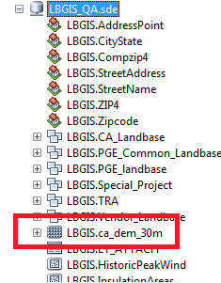

## Step 5. Configure the Workspaces

Create 2 SDE connection files the first should point to EDGIS (as user GIS_I), and the second must point to WIP (as user webr). Then configure the <Connection> xml node in the PLDBBatchProcess.Config.xml file to point to the workspaces. Double click on the connection files in ArcCatalog and verify that they connect correctly.

<Workspaces>

<Workspace>

<Name>Electric</Name>

<Connection>C:\Simon\Data\SDEConnections\EDGIS1Q.sde</Connection>

</Workspace>

<Workspace>

<Name>WIP</Name>

<Connection>C:\Simon\Data\SDEConnections\WIP1D.sde</Connection>

</Workspace>

</Workspaces>

## Step 6. Run the Software

Go to the command prompt

Navigate to the bin folder

Run the following command with parameters as below:

PLDBBatchProcess.exe -o SYNC_PLDB